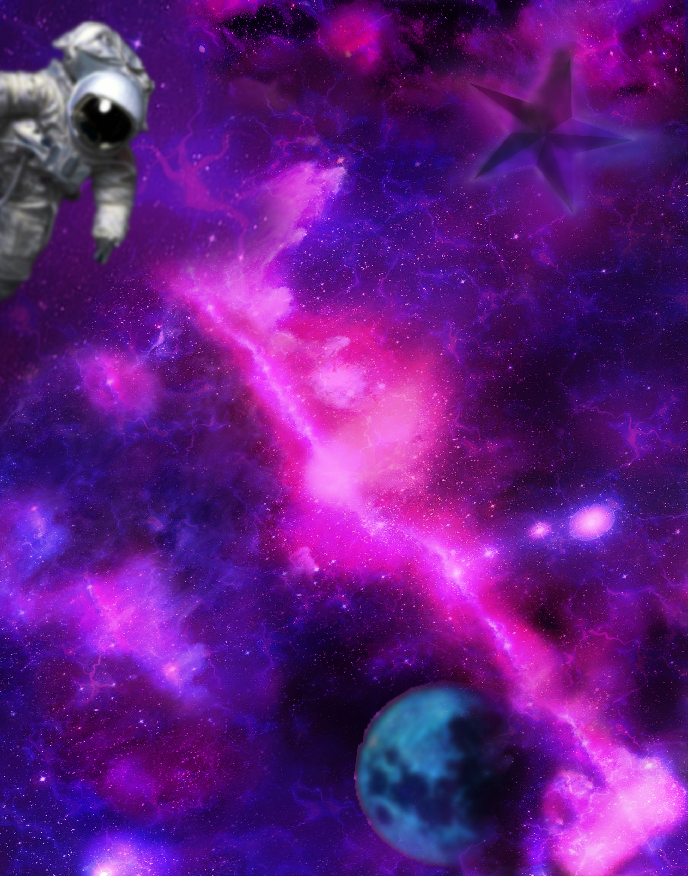

**THE ART**

**IN OUR WORLDS**

**NasArt**

Table of content

The Challenge

NASA is moving its data to the cloud, and Machine Learning/Artificial Intelligence (ML/AI) can offer an innovative means to analyze and use this massive archive of free and open data. Your challenge is to create an application using ML/AI techniques that allows users to input short text phrases, matches that input to NASA science data or imagery, and displays the results for the user in a creative and artistic manner.

Solution Summery

**High-level summary:**

The solution that we developed to Art in Our Worlds challenge is a web site that allows users to input short phrases (text or voice) and matches that input to NASA science data and imagery then displays the output in the following formats:

* Documents.
* Images.
* 3D images which can be accessed by virtual reality headsets.
* Images manipulated in an artistic manner.
* Funny filters with the output images.
* Videos.
* Images generated from text.

And the user can share all this data with others.

**Technical approaches:**

We developed a website to allow the user to access NASA’s data using the following algorithms and Artificial intelligence models:

* Speech recognition model for the search by voice feature using deep speech library.
* Document-to-document similarity using BERT
* Text to image using stable diffusion.
* text to speech using google API.
* language detection and translation using google API.
* Turning 2D images to 3D models using cube map functions.

**Project outcomes:**

The project provided great, creative, and interesting interface that helps both scientists, researchers, and public users to assess NASA’s data.

**Project Importance:**

The project made all this useful data accessible to the general public and all types of audience and the ability of sharing makes it easier to spread knowledge among the society.

**Detailed Project Description**

Project description in detail

NASA spends every year billions of dollars (25.2 billion dollars in fiscal year 2021), and this money has landed rovers on Mars, and even landed humans on the moon, building along the way a treasure of knowledge made with manpower and lots of time, but what good is this billion dollar knowledge if it’s not easily accessible and not all can benefit from it? So, this is the pipeline to hunt this treasure.

1. Extracting images and their description from NASA earth book

* There was a need for a dataset that has images, the images description, and where to find these images, we used NASA’s earth book found in the challenge’s resources to extract such dataset that is going to be used later when we are filtering the images.
* This is implemented using python programming language

1. Speech to Text Transcription

* There are many methodologies when designing a product, one of them is the design thinking methodology that one of its principles is user-centricity and empathy, so we wanted to target **visually impaired people** and facilitate their use of our website.
* It takes voice input from the user and maps it to its corresponding text
* It is implemented with machine learning using DeepSpeech model

1. Summarization model

* This machine learning model summarizes images and videos description so that the input to the similarity model is a little shorter thus much more efficient.
* The model used is SpaCy

1. Documents Similarity

* The core of the solution is allowing users to input short text phrases that gets matched with NASA science data or imagery.
* It takes input from the user that can be one word, or short text phrases.
* This feature is implemented with machine learning using BERT model (Bi-directional Representations from Transformers), that makes use of Transformer, an attention mechanism that learns contextual relations between words in a text, it return a list on indices containing the top 10 matches for the input text.

1. Creative Distortion of retrieved Images

* In this feature, we wanted to target the lovers of the space, showing them the retrieved picture from the similarity (if found) in many ways, creatively distorting it, we implemented 3 techniques that can do this.

1. Accessing a single-color channel of the image and changing its color map (needs one picture)
2. Taking 2 pictures and creatively blending them together (mix-up technique in data augmentation)
3. Taking 2 pictures and generating a third one using magenta, a pre trained style transfer generative adversarial network
4. Text to Speech

* This feature is continuation of the speech to text feature, to aid the visually impaired people with the search results.
* This machine learning model is Google Text to Speech, it is integrated with an API that can classify what is the input language

Tech Stack :

Our solution is implemented with:

Programming Languages : Python 3.9, JavaScript

Markup Language: HTML

Styling Language: CSS

Libraries used: ebooklib, numpy, pandas, wget, warning, os, BeautifulSoup, IPython,

Deepspeech, libasound2**-**dev, portaudio19**-**dev ,libportaudio2, libportaudiocpp0, ffmpeg, wave, nltk, sklearn, tensorflow_hub, matplotlib, cv2,PIL,random,zipfile, flask, pytextrank

, diffusers, transformers, scipy, mediapy ,deep_translator, gtts, langdetect

What exactly does it do?

hh

How does it work?

What benefits does it have?

What do you hope to achieve?

What tools, coding languages, hardware, or software did you use to develop your project

**Space Agency Data**

# **DATA Source**

# We used in our website data from” THE NASA API Portal” where NASA data, including imagery, is accessible to application developers. We used 2 APIs: Astronomy of The Day (AOTD) API, and NASA Image and Video Library API used to access the NASA Image and Video Library site at [images.nasa.gov](https://images.nasa.gov/#/).

**Data usage techniques**

**Hackathon journey**

**References**

Speech to text:

Deep speech Deep speech is made up of two pre-trained models that we have to download. It is made up of the Acoustic model and the Language model.